Early in the 1960s the first wave of smaller, lighter, more efficient cars from Europe, like the Mini and the Volkswagen Beetle began to make inroads in the American market. To counter this GM di two things: they either came up with all new designs like the Chevy Corvair, or looked to make the smallest cars in the lineup more efficient. That was the case with Oldsmobile. Olds looked to its F85 Cutlass. Still large by Eurpoean standards, it was nonetheless one of the American firm’s smaller offerings and it came with a positively minuscule 3.5-litre V8 as a more efficient option.
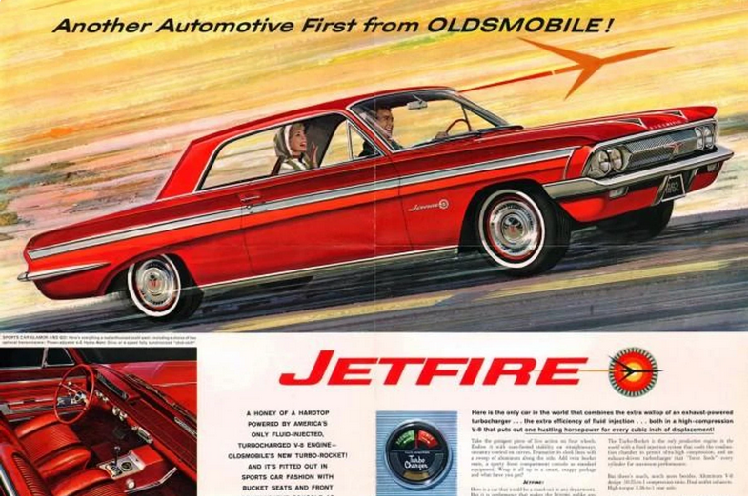
To improve fuel economy without sacrificing the performance of a ‘big’ V8, Oldsmobile struck up an interesting partnership with Garrett Corporation, which at the time only made industrial turbochargers. Together, the two giants developed automotive-suitable blowers with a smaller diameter and internal combustion-focused pipework to make it run. This T5 turbocharger was simply a bolt-on design that was installed onto a special version of the unibody F85 Cutlass called the Jetfire. Some people say it was the first turbocharged production car in the world. Others say the Chevrolet Corvair Monza Spyder Turbo emerged a couple of weeks sooner
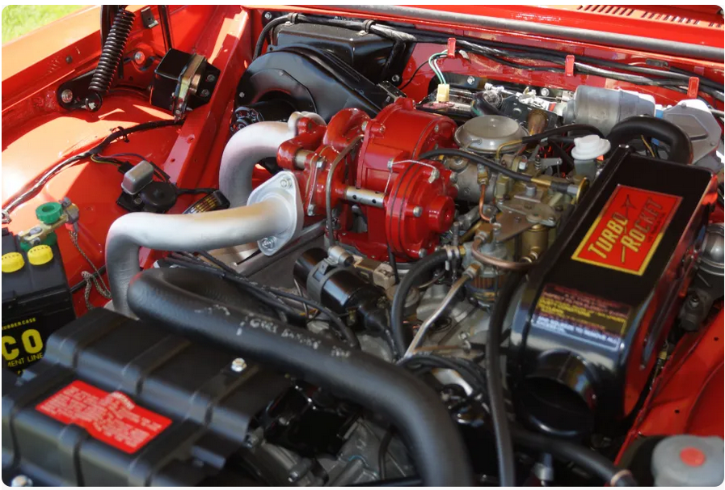
Equipped with the Garrett AiResearch turbocharger and carburetor, the Turbo-Rocket engine was rated at 215 bhp at 4,600 rpm and 300 lb⋅ft at 3,200 rpm. The Jetfire came with bucket seats and console, unique trim—two chrome fins on the hood and full-length contrast stripes on the bodysides—and a pressure/vacuum gauge mounted in the console (where it was almost hidden). Although much faster than a standard F-85, the Jetfire was criticized for having the same soft suspension as its less-powerful brothers, for its lack of a tachometer and other instruments, and for the poor shift quality of both the automatic transmission and the optional four-speed. Car and Driver tested an automatic Jetfire and obtained a 0–60 time of 9.2 seconds, with a top speed of 110 mph. The Jetfire's high cost (nearly $300 over a standard Cutlass hardtop) and reliability problems with its turbocharged engines limited sales to 3,765.
Ultimately the Jetfire engine was far ahead of its time. With forced induction and an already high compression ratio, the Jetfire was capable of producing more torque than a naturally aspirated engine that was twice its size, significantly improving the engine's efficiency and usability in real-life driving conditions, turbo lag not being an issue at motorway speeds. But since turbo and supercharging the engine essentially means forcing the compression in the combustion chamber even higher, the Jetfire was prone to 'spark-knock' and without modern engine management systems, the only way to mitigate this was to use a 50/50 mixture of methanol and distilled water The system needed to spray it into the intake air stream from a bottle reservoir next to the engine to cool it and keep combustion temperatures lower. This was actually labeled “Rocket Fuel
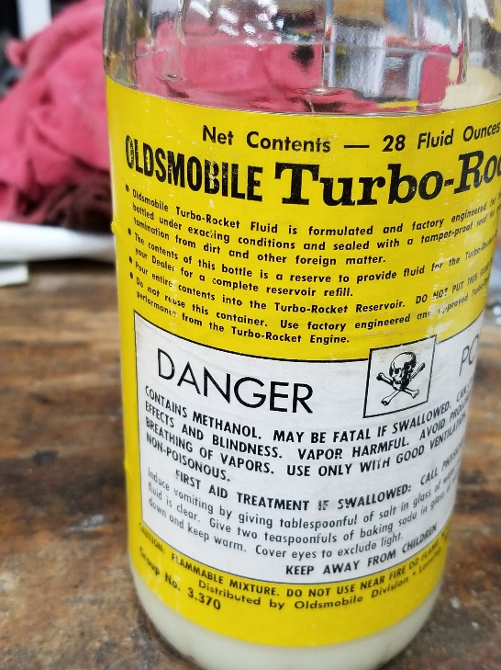
Let the bottle run dry and the Jetfire protected itself by entering into a low-power mode where the boost pressure was limited by a butterfly valve. Of course people forgot to top-up the bottle. Scores of owners took their Jetfires back to their dealers complaining about loss of power This proved too much of a hassle for people and buyers turned off the idea. The fuel injection system was reportedly erratic, too, causing many problems of its own. Plenty of Jetfire owners lost patience with Oldsmobile and the company actually ended up retro-fitting a four-barrel carburetor to fix it.
By 1964 the US had become a bit bored of small European cars and turned back to big V8s en masse. The Pontiac GTO was just over the horizon. The Jetfire was dropped as the F85 was restyled for 1964. The day of the turbocharged engine was done for a few years. The next car to use it? The BMW 2002 in 1970.
Herer’s link to a video Jetfire commercial: https://www.youtube.com/watch?v=mm4wlocZRz8
Here the Hemmings auction ad that piqued my interest:
https://www.hemmings.com/auction/1963-oldsmobile-jetfire-mooresville-nc-879342?utm_medium=email&utm_source=auctions_newsletter

